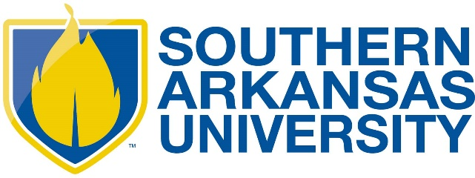

SOUTHERN ARKANSAS UNIVERSITY STUDENT ORGANIZATION RISK MANAGEMENT POLICY
Updated October 2022

All Southern Arkansas University student organizations are responsible to adhere to the following risk management policies. It should be noted that organizations are responsible to adhere to the risk management policies of the university and their organization. Organizational policy cannot supersede the policy of the university.

ALCOHOL AND DRUGS

1. Southern Arkansas University does not permit the use, possession, sale, or distribution of alcohol by students on its campus or at any student organization event. Alcohol is prohibited at any event sponsored by a student organization or at any event an observer would associate with the organization.

2. No alcoholic beverages should be purchased through or with student organization funds nor should the purchase of same for members or guests be undertaken or coordinated by any member in the name of or on behalf of the organization. The purchase or use of a bulk quantity or common source(s) of alcoholic beverage, for example, kegs or cases, is prohibited.

3. No members, collectively or individually, should purchase for, serve to, or sell alcoholic beverages to any minor (i.e., those under legal drinking age).

4. The possession, sale or use of any ILLEGAL DRUGS or CONTROLLED SUBSTANCES while on university premises or during a student organization event or at any event that an observer would associate with the fraternity is prohibited.

5. No student organization should co-sponsor an event with an alcohol distributor or tavern (tavern defined as an establishment generating more than half of annual gross sales from alcohol) at which alcohol is given away, sold or otherwise provided to those present. This includes any event held in, at or on the property of a tavern as defined above for purposes of fundraising. However, a chapter may rent or use a room or area in a tavern as defined above for a closed event held within the provisions of this policy.

6. No chapter should co-sponsor, co-finance or attend or participate in a function at which alcohol is purchased by any of the host chapters, groups or organizations.

7. All recruitment or rush activities associated with any chapter should be non-alcoholic. No recruitment or rush activities associated with any chapter should be held at or in conjunction with a tavern or alcohol distributor as defined in this policy.

8. No organization or member or pledge, associate/new member or novice should permit, tolerate, encourage or participate in "drinking games.” The definition of drinking games includes but is not limited to the consumption of shots of alcohol, liquor or alcoholic beverages, the practice of consuming shots equating to one’s age, “beer pong,” “century club,” “dares,” any sort of forced work, or any other activity involving the consumption of alcohol which involves duress or encouragement related to the consumption of alcohol.

10. No alcohol should be present at any pledge/associate member/new member/novice program, activity or ritual of the organization. This includes but is not limited to activities associated with “bid night,” “big brother – little brother” events or activities, / “big sister - little sister” events or activities, “family” events or activities and initiation.

HAZING

No organization, chapter, colony, student or alumnus should conduct, participate in nor condone hazing activities. Permission or approval by a person being hazed is not a defense. Hazing activities are defined as: "Any action taken or situation created, intentionally, whether on or off fraternity premises, to produce mental or physical discomfort, embarrassment, harassment, or ridicule. Such activities may include but are not limited to the following: use of alcohol, paddling in any form, creation of excessive fatigue, physical and psychological shocks, quests, treasure hunts, scavenger hunts, road trips or any other such activities carried on outside or inside of the confines of the chapter house; wearing of public apparel which is conspicuous and not normally in good taste, engaging in public stunts and buffoonery, morally degrading or humiliating games and activities, and any other activities which are not consistent with academic achievement, fraternal law, ritual or policy or the regulations and policies of the educational institution or applicable state law."

SEXUAL ABUSE AND HARASSMENT

An organization should not tolerate or condone any form of sexist or sexually abusive behavior on the part of its members, whether physical, mental or emotional. This is to include any actions, activities or events, whether on university premises or an off-site location which are demeaning to women or men, including but not limited to verbal harassment, sexual assault by individuals or members acting together. The employment or use of strippers, exotic dancers or similar, whether professional or amateur, at a student organization event as defined in this policy should not be allowed. Any incidents of sexual assault, stalking, or harassment should be immediately reported to University Police at 235-4100 and Title IX.

FIRE, HEALTH AND SAFETY

1. All student organization events should meet all local fire and health codes and standards.
2. The possession and/or use of firearms or explosive or incendiary devices of any kind at a student organization event is prohibited.
3. Candles are prohibited in university buildings.

EDUCATION

Each student organization should annually instruct its students and alumni/alumnae in its risk management policies and practices. It is recommended that all undergraduates and key volunteers receive on an annual basis a copy of the organization risk management policy and that a copy of the policy be posted on the organization website.
IMPORTANT LINKS
SAU Student Activities
SAU Greek Life
University Police Department
SAU Title IX
University Housing
SAU Student Life

