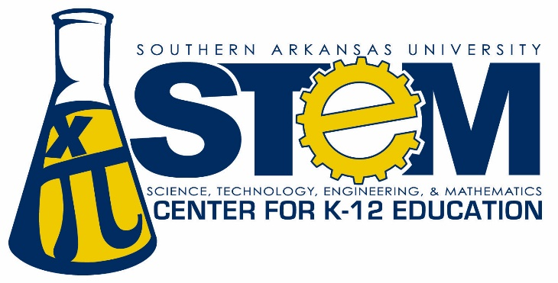

http://web.saumag.edu/science/stem/

https://web.saumag.edu/science/stem/science-fair/

SAU will host regional science fair
Southern Arkansas University will host the Annual Southwest Arkansas Regional Science Fair from 7:30 a.m. until 2:00 p.m., Friday, March 16, on the SAU campus.
Science Fair Director, Dr. Scott White (Associate Professor of Chemistry) announced that more than 300 third- through twelfth-grade students will be on hand at SAU representing over 260 science projects. These students were the top three winners in their grades and category at their schools.
Elementary (third- through sixth-grade) awards will be announced at 1 PM in the Reynolds Center Grand Hall. Awards for grades 7-12 will be announced at 1 PM in Reynolds Center Foundation Hall.
Judging will take place from 9:30 a.m. until 11:30 A.M. Public viewing of the projects will be available from 11:30 a.m. until 1 p.m in the W.T. Watson Gymnasium, after the judging is complete.
Over 20 schools will be represented by students from Bearden, Bradley, Emerson, Genoa, Harmony Grove, Heart Homeschool, Junction City, Lafayette County, Magnolia, Taylor and Texarkana, and Westside Christian school districts.
The Southwest Arkansas Regional Science Fair is co-sponsored by Southern Arkansas University, SAU College of Science & Engineering, the SAU STEM Center for K-12 Education and the South Central Service Cooperative in Camden, with special thanks to the SAU Physical Plant, S&S Ace Hardware and Mulerider Athletics. The fair’s cooperate sponsor is Albemarle Corporation.

