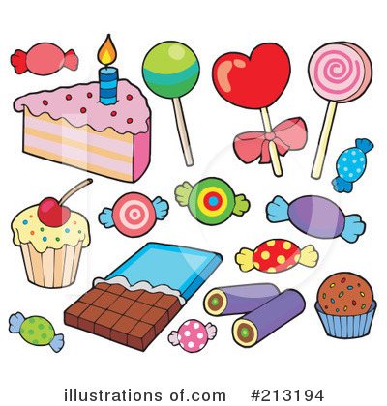**Charlie and the chocolate factory**

Lesson created by: Dr. Jennifer Logan

CEER Director, Southern Arkansas University

Time required: 2-3 class periods

Suggested Grade Level: 3-5

**Arkansas Standards of Learning – Social Studies/Economics**

**E.5.4.2:** Articulate ways entrepreneurs and businesses in Arkansas and the United States organize human, natural, and capital resources to produce goods and services.

**EDM.1.E.1:** Evaluate the roles of *scarcity*, incentives, trade-offs, and *opportunity cost* in decision making

**EM.2.E.1:** Identify various *allocation methods* used in different circumstances, countries, and economies (e.g. price, auction, lottery, *fiat*)

**Additional Skills:** Critical Thinking using Deductive Reasoning

Math skills using Exchange Rates

Writing practice using assignments

**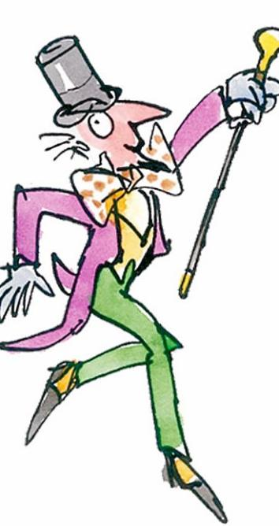*Economic Concepts*:**

**Allocation Method –** method by which goods and services are distributed in an economy

**Benefit –** an advantage or profit gained from something

**Capital resource** – resource made and used to produce and distribute goods and services

**Consumer –** person who buys or rents goods or services and uses them

**Demand** – quantity of a good or service that buyers are willing and able to buy at all possible prices during a period of time

**Entrepreneur** – person who organizes, operates, and assumes the risk for a business hoping to make a profit

**Exchange rates** – the price of a nation’s currency in terms of another currency

**Good** – item used and/or consumed for enjoyment

**Human resource** – person who does the mental and physical work to produce goods and services

**Income** – money that is earned from work, investments, and businesses

**Market** – place, institution, or technological arrangement where or by means of which goods or services are exchanged

**Natural resource** – something, such as a forest, a mineral deposit, or fresh water, that is found in nature and is necessary or useful to humans

**Opportunity Cost –** highest value alternative that must be given up when scarce resources are used for one purpose instead of another

**Scarcity –** result of an inability to satisfy unlimited wants with limited resources

**Supply** – quantity of a good or service that producers are willing and able to sell at all possible prices during a certain period of time

**Trade-Off-** a choice that involves giving up one thing to have more of another

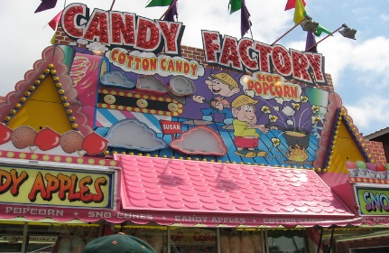

**Activity #1: Personal Characteristics**

People often have various personal characteristics that define their actions and help to anticipate their response when making a decision:

* **Brave**
* **Honest**
* **Curious**
* **Polite**
* **Adventurous**
* **Enthusiastic**
* **Caring**
* **Responsible**

**Question:** Assume you were in Charlie’s shoes. You now have an opportunity to explore the famous Wonka Chocolate Factory. Are the rumors true? Who does Mr. Wonka have working for him to help produce such delightful candies? What characteristics will Charlie find most helpful on his tour of the factory? Order the characteristics from most to least important for Charlie’s upcoming tour. Please explain your answer by referencing the text.

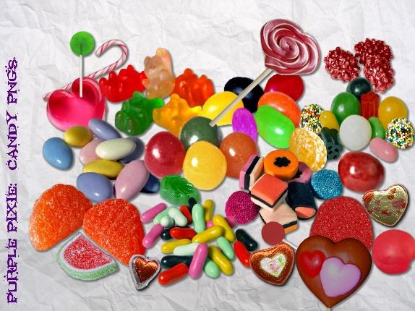**Activity #2: Design Your Own Candy**

**Writing Assignment:** Everybody likes some type of candy, right? We all have our most and least favorite types of candy. What is your favorite type of candy? What does it taste like? How is it shaped? What does the packaging look like? What is the “target market” for that particular type of candy? Write a brief essay explaining your candy design. Be sure to specify how the candy looks and tastes. Also be sure to discuss packaging and the desired market for your candy design. .

**Part b**. Consider a longer project where students illustrate their candy design through drawing, collage, or computer generation. Students can then present their candy design to the class when time permits.

**Activity #3: Allocation Methods**

There are many ways in which resources can be allocated. These allocation methods include:

* **First Come, First Served**
* **Lottery**
* **Contest**
* **Auction**
* **Personal Characteristic**
* **Authority/Fiat**
* **Voting/Majority Rules**
* **Price**

**Question:** Assume you were Willy Wonka, ready to show the world your secrets by inviting 5 lucky individuals to tour your famous candy factory. What allocation method would you employ for distributing the golden tickets? What are a few of the challenges you may face with this selection? Why is your selection considered the best method in this case? Please explain.

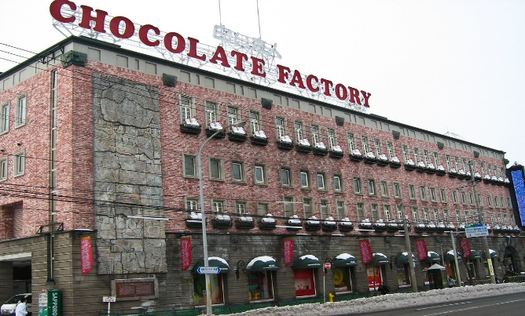**Activity 4: Wonka Chocolate Factory and Local Production**

Willy Wonka’s famous Chocolate Factory is described to be 50 times larger than any other building in the city. The factory produces chocolate confections along with all other sorts of tasty sugary treats. Let’s compare this description to large producers in your home town.

What large producers are located in your home town? __________________________________

__________________________________________________________________________________________________________________________________________________________________________________________________________________________________________

Do any members of your household work for a local large producer mentioned above? ________

__________________________________________________________________________________________________________________________________________________________________________________________________________________________________________

What goods and services do these large producers make? _______________________________

__________________________________________________________________________________________________________________________________________________________________________________________________________________________________________

Does your household consume any of the goods and services described above? ______________

__________________________________________________________________________________________________________________________________________________________________________________________________________________________________________

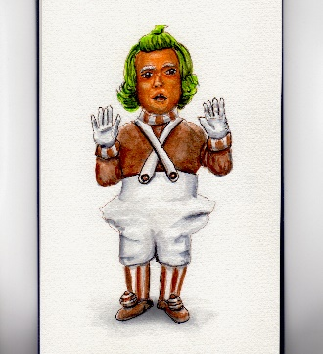**Activity 5: Logic Problem**

Using the clues provided below, select the appropriate matches in the table to determine each child’s name, favorite thing, and the end of their factory tour.



**Clues:**

1. The boy who loves eating falls in to a chocolate river.
2. Veruca is a spoiled girl who demands presents from her parents.
3. Violet blows up into a big blueberry.
4. The boy who ends up stuck in a television has the last name Teavee.
5. Charlie Bucket loves chocolate.
6. Miss Beauregarde loves to chew gum.
7. The boy who loves chocolate becomes the new factory owner.
8. The girl that demands presents is called a “bad nut” by squirrels.

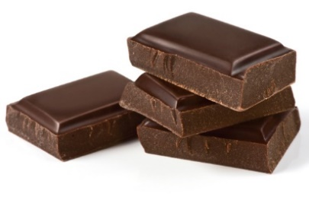**Activity #6: Substitutes and Complements of Chocolate- So Many Choices!**

Instructions: Circle the following terms in the Word Search puzzle. Once this step is completed, determine if each term is a substitute or complement of chocolate and list in the appropriate category below.

Caramel Milk Popcorn

Granola Nerds Skittles

Honey Nuts Strawberries

Marshmallows Peppermint Toffee

D C T A W A I X Q P Z S S N R O C P O P

Y A V J V D L D B B E Y W E K B F V G C

K R J Q P M T Y M I Q D O I Q G I C P V

L A I I M B Y M R L J V L R U V G F S T

U M Y R M A M R C O T J L E I T Z X O A

I E L P E C E Q Q J E A A B T E Q L I N

N L J W G B J U A V C S M O U J F F H W

X V S D W T L L H O D P H O H J Y Q A T

K M D A P I N U R R D D S X Z M M I L K

U S R E O S J Y E X J L R V C M R W B V

D T K G E A R N S K Z U A Q D O B S H D

S J B I V F P E P P E R M I N T G B J D

T H Y U T P F N G R Z D W P E R Y B X E

M I Q P V T N O U K J L J C A X E L U B

T W V A R Y L J T T R H J N J Y N U E D

E Y R E S J M E V W S B O F P W O D Z L

F X M N G C F W S B I L S X M Y H P H J

A F G K P Z T P E X A G R P C P E X Y B

E T B Y B U Z Z P P U J G L A V V U U D

G T M P Q U G Z P T B T X E W I H T B X

**Substitutes Complements**

**_______________________________ ____________________________________**

**_______________________________ ____________________________________**

**_______________________________ ____________________________________**

**_______________________________ ____________________________________**

**_______________________________ ____________________________________**

**_______________________________ ____________________________________**

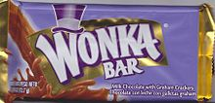**Activity 7: Match Up Madness**

Match each description on the left with the correct term listed on the right.

1. Willy Wonka is an ______________ in the Natural Resource

chocolate industry.

1. Charlie buys a chocolate bar, so Charlie Supply

is a ____________.

1. Oompa Loompas serve as a “not so human” Market

__________________ for the factory.

1. Unlimited candy wants in a world of limited Opportunity Cost

candy resources demonstrates ___________.

1. Sugar cane is a valuable ____________ for

candy producers. Income

1. A candy store provides a ______________

for buyers and sellers to make an exchange. Human Resource

1. Consumer __________ for candy increases

around Halloween. Scarcity

1. The Everlasting Gobstopper is a _________. Consumer
2. Attending the factory tour rather than school

makes school Charlie’s ________________. Entrepreneur

1. The taffee stretching machine is an example

of a ________________________. Demand

1. Mr. Bucket’s job at the toothpaste factory

provides a very small __________ for

the Bucket family. Good

1. Factories such as Willy Wonka’s ________

candy to local stores. Capital Resource

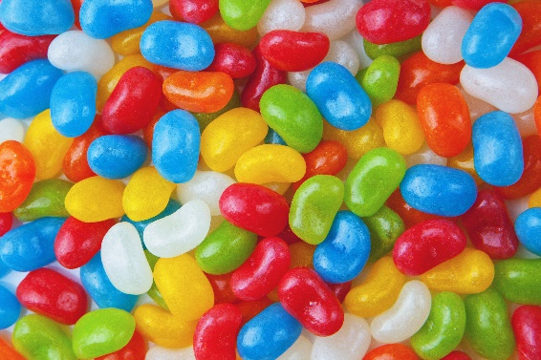**Activity 8: Candy Exchange in Candyland – Exchange Rates**

Calculate the given prices in terms of the commodity asked for in each question using the candy exchange rates provided below. Be sure to show your work.

Suppose 1 candy bar (cb) = 2 gummy fruits (gf)

1 gummy fruit (gf) =2 twixlers (t)

1 popcorn (p) = 5 candy bars (cb)

1. Assume the price of a bag of jelly beans is 3 candy bars. But you only have gummy fruit. How many gummy fruits will the jelly beans cost you?
2. Suppose a box of sour tarts costs 3 popcorns. What is the cost in candy bars?
3. Assume a pint of ice cream costs 20 twixlers. What is the cost in popcorn?

**Activity #9:** Step right up! Five lucky individuals will have a chance to tour the famous Wonka Factory if they can get their hands on one of the prized golden tickets. See if you can find your way through the maze. Top finishers may receive a prize for their efforts!

**START**





**Activity #10: Media Platforms** 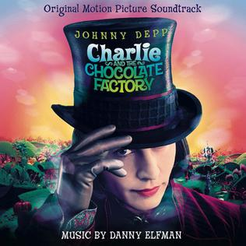

Watch *Charlie and the Chocolate Factory* on video. Does the video portrayal of Charlie Bucket differ from the one illustrated in the book? Please explain in your own words.